ZINDA FESTIVAL 2019
Musician and Performer Expression of Interest
Zinda Festival celebrates regional Victoria’s cultural diversity- the music, dance, food and cultures that contribute to the vibrancy of our community. It will run from March 16th to March 22nd. Building on the success of the Bendigo Festival of Cultures, this year we are re-launching the festival as “Zinda Festival”. Zinda means alive and lively in a number of languages- Dari, Bengali, Farsi, Hindi, Hazaraghi and Urdu. It is therefore a truly multicultural name for our multicultural festival. Zinda Festival is presented by Loddon Campaspe Multicultural Services.
If you are a musician or performer who is Indigenous or from a culturally diverse background who would like to play at Zinda Festival, we would love to hear from you! Please note, as there are limited places, not all performers will be able to be offered a place.
Musician / Band Name:

Contact Name:

Email:

Contact Phone Number:

Current Location:

Description of performance/type of music/ (short is fine- 100 words or dot points)
Technical requirements e.g.: floor surface, PA (dot points are fine- we will ask for more detail later)
Links to (Website/Facebook/YouTube/SoundCloud)
Do you require payment or are you a volunteer group? If volunteer, will you require reimbursement for costs, and if so, what are these?

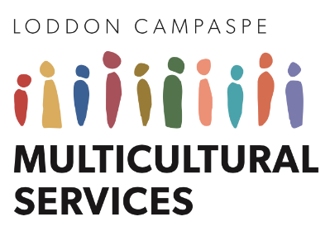
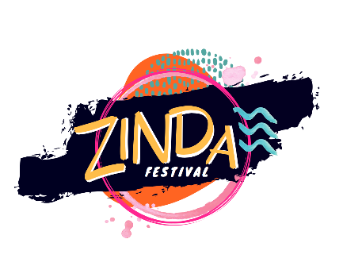
Please give or email this form to Meese Wanefalea at: Multicultural Services, 120 McCrae Street Bendigo or at m.wanefalea@lcms.org.au.

